16.Demonstrate simple web application using java or python and host it in any public cloud Service provider (AZURE/GCP/AWS) to demonstrate platform as a service (Paas).

1. create a azure account

Then after click on app services and create.

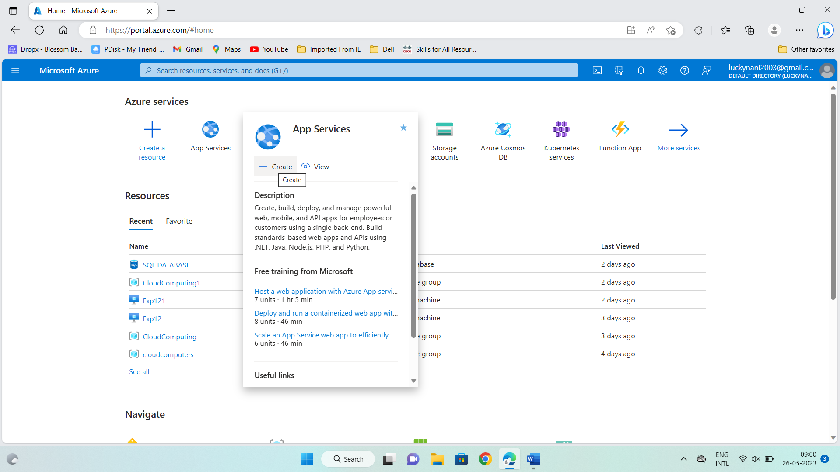

2. create a resource group, name of the database

Give run time stack is<<Node 14 LTS>>

Os(linux)

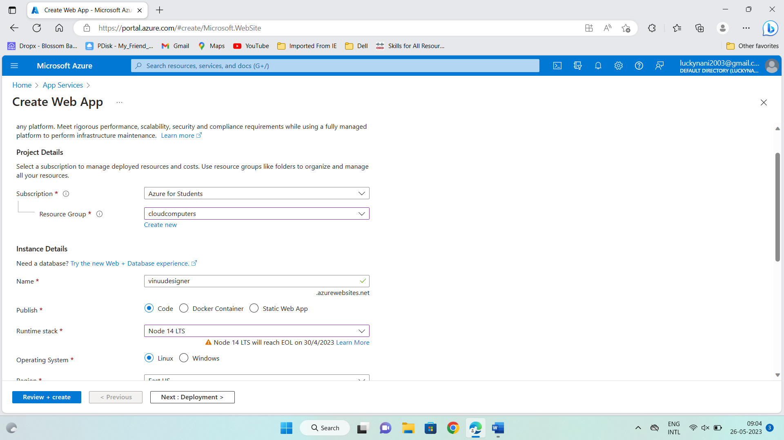

Click on create and review.

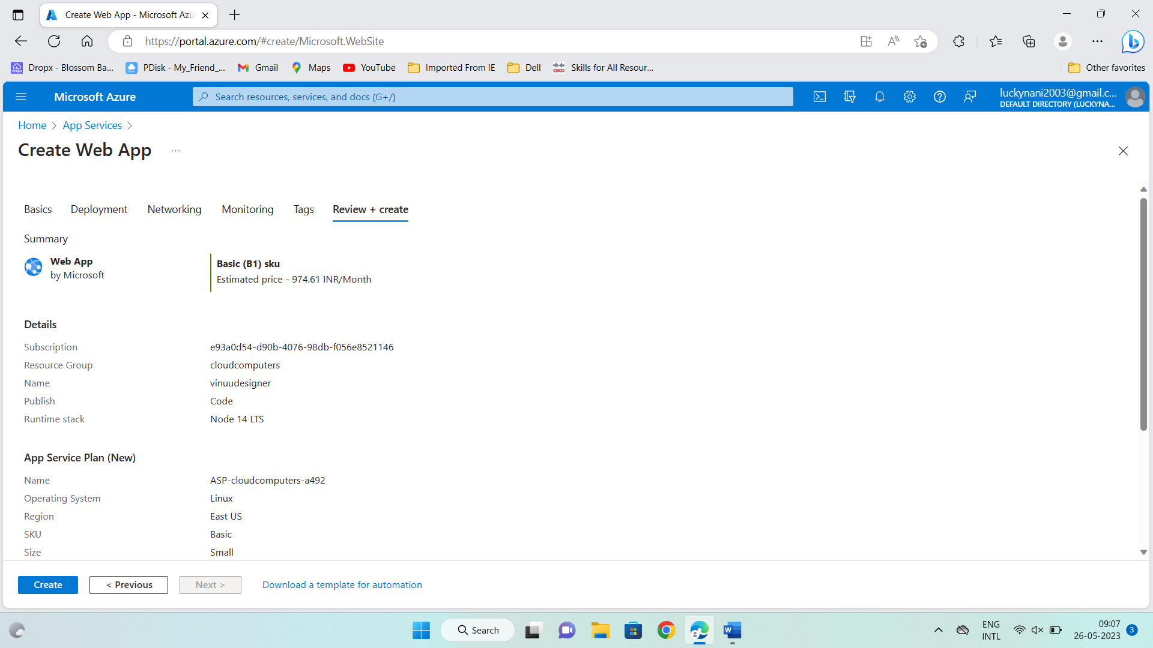

Click on create…..

And wait for few for initializing of deployment

After processing completion click on go to resource….

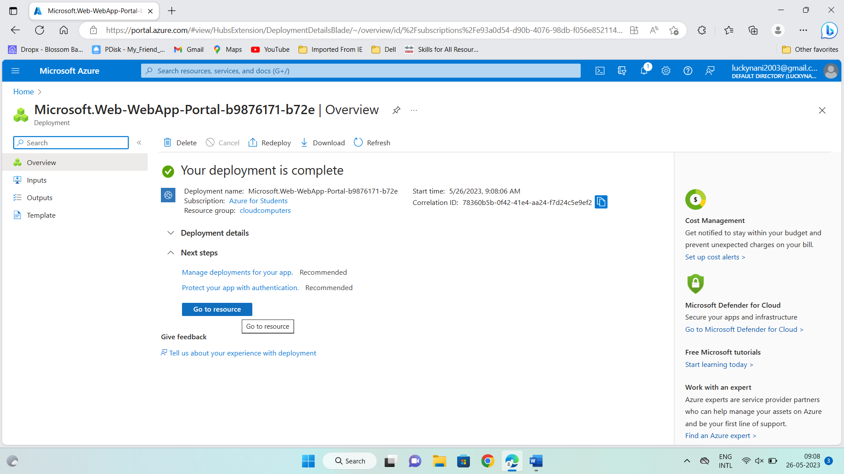

Then after…

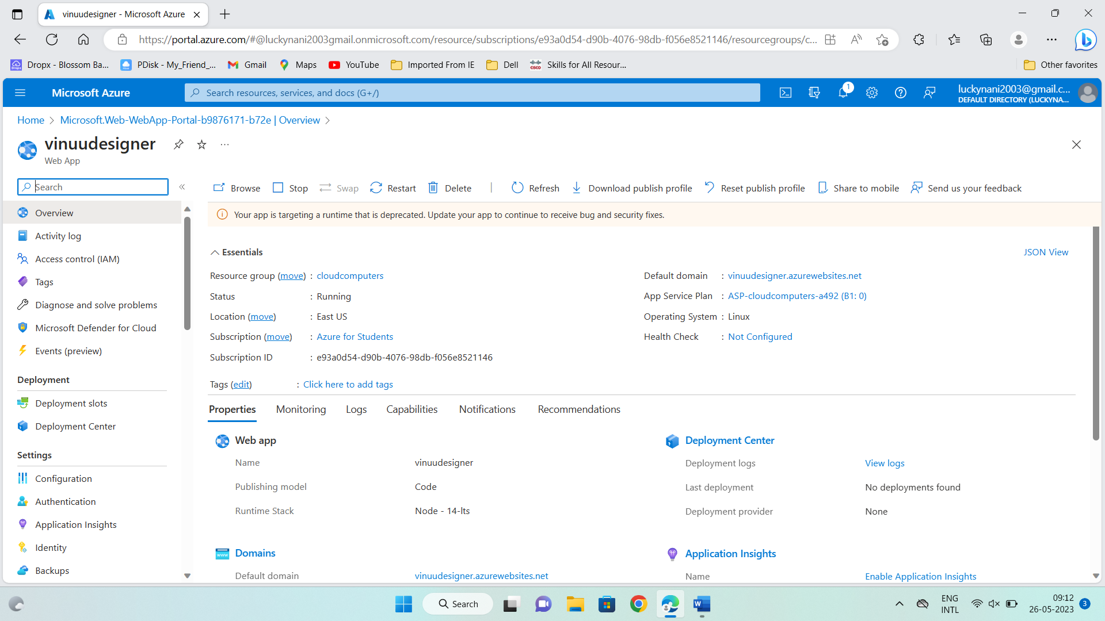

Take the copy of the url/default domain if the link….

And paste in new tab….

Your web application is created….

